TAN TAO UNIVERSITY
SCHOOL OF INFORMATION TECHNOLOGY


Report of Final Project

BEER DISTRIBUTION SYSTEM

Course: Introduction to Database System (CS311V)
Fall 2025

Group 2
Member 1: Le Chi Tam
Member 2: Duong The Hien
Member 3: Le Nguyen Quoc Anh
Student code: 2302220
Student code: 2302251
Student code: 2302283

Supervisor: Cao Tien Dung, PhD
Tay Ninh, November 2025

TABLE OF CONTENTS
__________

BEER DISTRIBUTION SYSTEM 0

I. Project Introduction: Beer distribution system: 3
1. Define the problem: 3
2. Key System Functions: 3

II. Overview of the Architecture: 4
1. General Architecture: 4
2. Work flows: 4

III. Database Design: 5
1. Entity - Relationship: 5
2. Figure and explanation of the ER: 6
3. Transforming ERD to Tables: 8
4. Constraints/ Rules + Norms: 8
5. SQL Claude: 14

IV. Implementation: 15
1. MySQL: 15
2. API: 15
3. Library: 16
4. GUI: 17

V. Conclusion: 17

VI. References: 18

- Link slide: https://www.canva.com/design/DAG6j_s0nuA/dofEMF4V4vHPKi9VQdPvLw/edit?utm_content=DAG6j_s0nuA&utm_campaign=designshare&utm_medium=link2&utm_source=sharebutton

Project Introduction: Beer distribution system:

Define the problem:
In today's digital economy, the use of advanced management systems to improve operational efficiency and business oversight has emerged as a key element in boosting competitiveness and overall success. The Beer Distribution System project is designed to modernize distribution operations, particularly within the beverage industry. This system has been built using Pycharm and My SQL as the database foundation to guarantee reliability and the potential for future growth.
The system aims to digitize distribution workflows and automate essential tasks in the beer supply chain, featuring core database tables such as customers, orders, products, suppliers, and inventory. These capabilities are intended to enhance operational efficiency, strengthen supply chain coordination, and maximize business performance by simplifying distribution processes and effectively managing data.

Key System Functions:
Customer Management: The system allows for the creation, authorization, and management of customer accounts, including details such as contact information and loyalty points. This access control ensures efficient customer relationship management, optimizing service delivery and enhancing customer retention.
Order Processing and Management: The system automates the process of receiving and handling customer orders, including recording order details, total amounts, tax, shipping costs, and status in real-time. This optimizes the distribution workflow, improves delivery efficiency, and enhances the customer experience.
Supplier Coordination: The system manages supplier data and supply agreements, tracking quantities, supply dates, and contract terms to ensure a steady flow of products. This enhances procurement efficiency and supports effective supply chain coordination.
Inventory Tracking and Logging: The system automates inventory management by recording imports, exports, and quantity changes through detailed logs. This functionality supports accurate stock monitoring, reduces discrepancies, and provides insights for inventory optimization.
Payment and Delivery Management: The system handles payment methods and statuses, alongside delivery dates, ensuring accurate financial tracking and timely order fulfillment, thereby improving cash flow management and customer satisfaction.

Overview of the Architecture:

General Architecture:

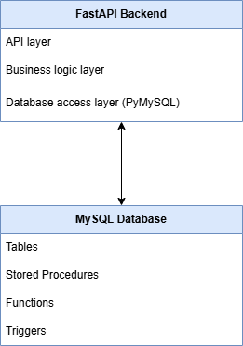

API Layer – FastAPI

This layer exposes RESTful API endpoints to external clients or system operators.
It handles:
- Receiving HTTP requests
- Validating input parameters
- Forwarding requests to the Business Logic layer
- Returning JSON responses
Example endpoints include:
- /add-customer
- /add-order
- /add-order-detail
- /process-exim
- /get-stock
The API Layer does not contain business rules; it only coordinates logic and communicates with deeper layers.

Business Logic Layer (MySQL Stored Procedures, Functions, Triggers)
In this system, most core business logic is implemented directly inside MySQL to ensure consistency, performance, and transactional safety.
This layer includes:

Stored Procedures
Handle complex operations such as:
- Generating new customer and order IDs
- Creating new orders
- Adding order details
- Handling import/export inventory movements
- Updating order statuses
Examples:
AddNewCustomer, AddNewOrder, AddOrderDetail, ProcessExIm

Functions
Return calculated values (read-only logic):
- fn_get_order_total() – calculates total value of an order
- fn_get_stock() – computes actual stock (import – export)
- fn_get_customer_total_spent()
- fn_get_customer_order_count()

Triggers
Automatically ensure data integrity:
- Update inventory quantities after import/export
- Recalculate order totals
- Add loyalty points when an order is paid
- Update audit timestamps for inventory changes
By keeping business rules inside MySQL, the system guarantees consistency even if future systems (e.g., mobile app, web app) also connect to the database.

Data Access Layer (Python–MySQL communication)
This layer provides a secure method for the API to interact with the database via:
- pymysql connections
- Parameterized queries
- Stored procedure calls (cursor.callproc())
The DAL is responsible only for:
- Opening/closing database connections
- Running SQL or executing stored procedures
- Returning results to the API layer
No business logic is implemented here.

Database (MySQL)
The database contains all business entities:
- Customers
- Orders
- OrderDetail
- Products
- Inventory
- Ex_Im (import/export logs)
- Suppliers
- Product_Supplier
The schema supports normalization, foreign keys, cascading deletes, and consistent auditing of inventory.

Work flows:
Some examples work flows:
Add new Customer:
Client → POST /add-customer
→ FastAPI → CALL AddNewCustomer
→ MySQL:
- Generate CUSxxx
- Insert into Customers
- Select new_customer_id
← FastAPI return JSON
Add new Order:
Client → POST /add-order
→ FastAPI → CALL AddNewOrder
→ MySQL:
- Generate ORDxxx
- Insert into Orders
- Select new_order_id
← FastAPI return JSON
Add new Order details:
Client → POST /add-order-detail
→ FastAPI → CALL AddOrderDetail
→ MySQL:
- Insert OrderDetail
- Update total_amount by using fn_get_order_total()
- Trigger trg_update_order_total (if exist)
Update Order status:
Client → PUT /update-order-status
→ FastAPI → CALL UpdateOrderStatus
→ MySQL:
- Update Orders
- Trigger trg_update_customer_loyalty if order status is Paid

Database Design:

Entity - Relationship:
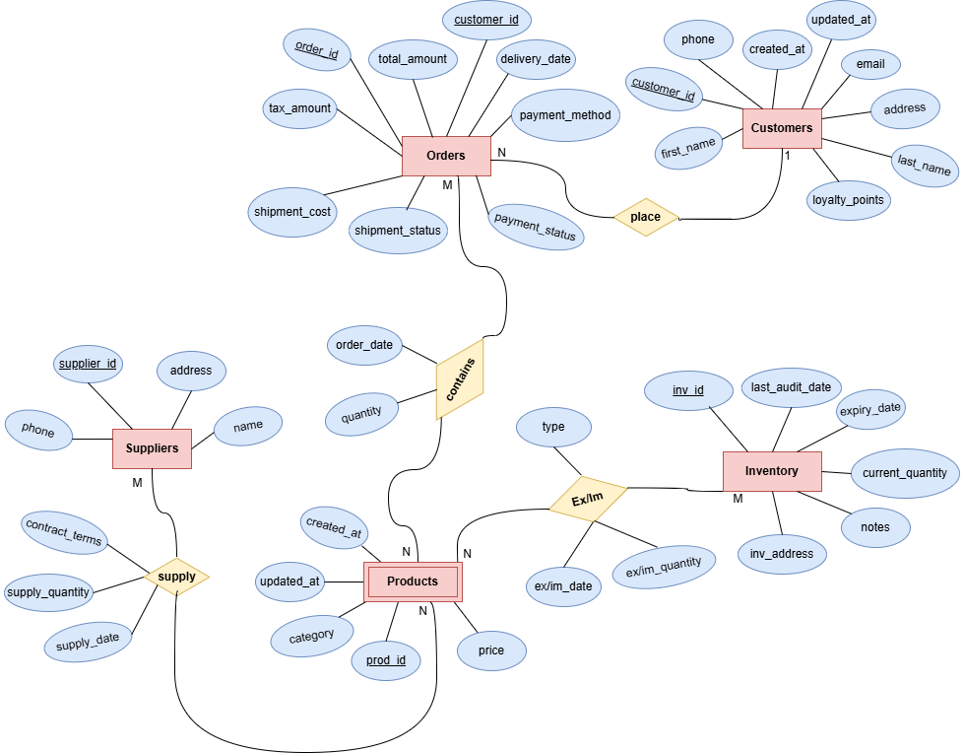

The Entity–Relationship (ER) model represents the logical structure of the Beer Distribution System. It defines how real-world business objects such as Customers, Orders, Products, Suppliers, and warehouses (Inventory) interact with each other in the system.
Each entity reflects a key data component of the business, while the relationships illustrate how transactions and workflows are connected across the supply chain.
This model ensures that the database is logically organized, normalized, and capable of supporting the system’s main operations efficiently.
The Beer Distribution System is structured around five main entities that represent the core components of its business operations: Customers, Orders, Products, Suppliers, and Inventory.
- Customers represent the buyers who place orders for beer products. This entity stores key identification and contact information to support customer relationship management and loyalty tracking.
- Orders record all transactions made by customers, including payment and shipment details, allowing the system to track the full order lifecycle from purchase to delivery.
- Products represent all beer items distributed or sold by the company. This entity serves as the central reference for other operations such as ordering, supplying, and storing.
- Suppliers contain information about companies or distributors that provide beer products to the system, supporting procurement and contract management.
- Inventory represents the warehouses where products are stored, tracking stock levels, expiration dates, and audits to ensure proper supply and storage management.
Together, these entities form the foundation of the ER model, supporting all major business functions—from purchasing and supply management to storage and sales distribution.
- Table of Relationships and Corresponding System Functions:
Relationship (Name & Type) | Detailed Description | Map to Function (Supported Feature)
place ( Customers → Orders ) → 1 – N | Represents the relationship between customers and orders: one customer can place multiple orders, but each order belongs to only one customer. The system uses this relationship to identify who places the order, track purchase history, and loyalty points. | Order Processing and Management – processing orders based on customer information.
contains ( Orders → Products ) → M – N | Indicates that one order can contain multiple products, and a product can appear in many different orders. The system records product details, quantity, price, tax, and total amount in each order. | Order Processing and Management – recording and processing detailed order items.
supply ( Suppliers → Products ) → M – N | Represents the relationship between suppliers and products: one supplier can provide many products, and a product can be supplied by multiple suppliers. Includes attributes like supply_quantity, supply_date, contract_terms to manage supply contracts and stock quantity. | Supplier Coordination – managing supplier data, contracts, and supply chain.
Ex/Im ( Products → Inventory ) → M – N | Records import/export (stock-in/out) operations between products and warehouse. Each log saves import/export_date, type (Import/Export), and quantity. Helps the system track inventory flow and maintain stock accuracy. | Inventory Tracking and Logging – supporting warehouse management and stock movement tracking.

Transforming ERD to Tables:
- Tables of entity:
Customers (PK (customer_id), first_name, last_name, email, phone, address, loyalty_points, created_at, updated_at)
Orders (PK (order_id), FK (customer_id), total_amount, tax_amount, shipment_cost, payment_method, payment_status, shipment_status, delivery_date)
Products (PK (prod_id), name, category, price, created_at, updated_at)
Suppliers (PK (supplier_id),name, address, phone)
Inventory (PK (inv_id), inv_address, expiry_date, current_quantity, notes, last_audit_date)
- Tables of relationship:
Product_Supplier (Pk (supplier_id, prod_id), contract_terms, supply_quantity, supply_date)
OrderDetail (PK (order_id, prod_id), quantity, order_date)
Ex_Im (PK (prod_id, inv_id,ex/im_date), type ,ex/im_quantity)
*Note: PK: Primary key, FK: Foreign key

Constraints/ Rules and Norms:
The database schema of the Beer Distribution System is designed with a series of constraints to ensure data integrity, consistency, and logical accuracy. These constraints prevent invalid data entry, preserve relationships between entities, and reflect real-world business rules such as unique customers, positive stock quantities, and valid payment or shipment statuses.
Each constraint was applied intentionally to represent the operational logic of the system and maintain normalization across all tables.

3.1. Primary Key Constraints:
Purpose:
Primary Keys (PK) uniquely identify each record in a table. They ensure that no two rows contain the same identifier, enabling accurate referencing across related entities.
Application in the System:
- Customers(customer_id) uniquely identifies each customer.
- Orders(order_id) identifies each purchase transaction.
- Products(prod_id) defines each product in the catalog.
- Suppliers(supplier_id) and Inventory(inv_id) ensure distinct warehouse and supplier records.
- Relationship tables such as OrderDetail, Product_Supplier, and Ex_Im use composite primary keys (e.g., (order_id, prod_id)) to prevent duplication in many-to-many relationships.
Reasoning:
This guarantees the uniqueness and traceability of every record — a fundamental principle of relational database design.

3.2. Foreign Key Constraints:
Purpose:
Foreign Keys (FK) maintain referential integrity between related tables. They ensure that every reference points to a valid record in its parent table.
Application in the System:
- Orders(customer_id) → Customers(customer_id)
- OrderDetail(order_id) → Orders(order_id)
- OrderDetail(prod_id) → Products(prod_id)
- Product_Supplier links Products and Suppliers.
- Ex_Im links Products and Inventory.
ON DELETE CASCADE:
Used to automatically remove dependent records when a parent record is deleted (e.g., deleting a customer deletes all their orders). This maintains database consistency and avoids orphan records.
Practical Justification:
In real-world systems, when an entity (like a customer or product) is removed, all dependent data must also be deleted or archived to keep the database clean and consistent.

UNIQUE Constraints
Purpose:
UNIQUE ensures that certain data fields — such as emails or phone numbers — cannot be duplicated, which is essential for accurate identification.
Application:
- Customers.email and Customers.phone are unique.
- Suppliers.phone is unique.
Reasoning:
This prevents data duplication and ensures that each customer or supplier can be contacted individually. It also avoids confusion in CRM systems and supports reliable authentication if needed.

CHECK Constraints
Purpose:
CHECK constraints ensure that column values comply with valid business rules and logical boundaries.
Examples and Justification:
Customers: loyalty_points >= 0 (Points cannot be negative)
Orders: total_amount >= 0, tax_amount >= 0, shipment_cost >= 0 (No negative monetary values)
Orders: payment_method IN ('Bank Transfer','Credit Card','Cash') (Restrict to valid payment methods)
Orders: shipment_status IN ('Pending','Confirmed','In Delivery','Delivered','Returned') (Restrict to real shipment states)
OrderDetail: quantity > 0 (Must order at least one unit)
Product_Supplier: supply_quantity > 0 (No zero-supply contracts)
Ex_Im: ex_im_quantity > 0 (Stock transactions must move positive quantities)
Products: price >= 0 (Prevent invalid product pricing)
Reasoning:
These constraints enforce logical correctness of business operations, prevent negative or invalid values, and simplify validation at the database level rather than relying only on application logic.

DEFAULT and Timestamp Constraints
Purpose:
DEFAULT values ensure that certain columns automatically receive valid data if not explicitly provided. Timestamps such as CURRENT_TIMESTAMP are used for tracking creation and update times.
Application:
- created_at and updated_at in Customers and Products → track changes automatically.
- Ex_Im.ex_im_date, OrderDetail.order_date, and Product_Supplier.supply_date default to the current date/time.
Reasoning:
This simplifies data entry and ensures auditability — every record is traceable in terms of when it was created or modified.

ON DELETE CASCADE
Purpose:
Maintains referential integrity by automatically deleting dependent records when a parent record is deleted.
Examples:
- Deleting a Customer → removes all related Orders and OrderDetail records.
- Deleting a Product → removes related records in OrderDetail, Product_Supplier, and Ex_Im.
- Deleting a Supplier → removes all linked supply contracts.
Reasoning:
This ensures no orphan records remain in relationship tables. It reflects realistic business behavior — when a supplier or product is removed, all dependent transactions should be cleared or archived accordingly.
Alternative:
If historical tracking is required, ON DELETE SET NULL or RESTRICT could be used instead of CASCADE.

ENUM Constraints
Purpose:
To limit the input values of certain attributes to a predefined list, avoiding invalid entries.
Example:
In Ex_Im, type ENUM('Export','Import') ensures that transactions are categorized as either an Import or Export.
Reasoning:
This simplifies data validation and guarantees that all inventory movements have a valid, consistent classification.

Business Logic Summary
PRIMARY KEY: Ensure unique identification (Prevent duplicate records)
FOREIGN KEY: Maintain referential integrity (Keep links valid between entities)
UNIQUE: Prevent duplication of key info (Guarantee distinct contact data)
CHECK: Enforce logical conditions (Prevent invalid or illogical input)
DEFAULT / TIMESTAMP: Automate data population (Improve traceability)
ENUM: Restrict data to valid options (Prevent incorrect status entries)
ON DELETE CASCADE: Auto-clean dependent data (Maintain consistency across tables)

- Conclusion:
The applied constraints collectively enforce both technical integrity and business logic of the Beer Distribution System. They ensure that data remains accurate, non-redundant, and consistent. Invalid inputs (e.g., negative prices, undefined statuses) are blocked. All relationships (Customer–Order, Product–Supplier, Product–Inventory) stay synchronized. By combining structural rules (PK, FK, UNIQUE) with logical rules (CHECK, ENUM), the system achieves a fully normalized and business-safe database design.

Customers:
Column Name | Data Type | Constraints
customer_id | VARCHAR(10) | PRIMARY KEY
first_name | VARCHAR(50) | NOT NULL
last_name | VARCHAR(50) | NOT NULL
email | VARCHAR(100) | UNIQUE, NOT NULL
phone | VARCHAR(15) | UNIQUE
address | VARCHAR(255)
loyalty_points | INT | DEFAULT 0, CHECK (loyalty_points >= 0)
created_at | DATETIME | DEFAULT CURRENT_TIMESTAMP
updated_at | DATETIME | DEFAULT CURRENT_TIMESTAMP ON UPDATE CURRENT_TIMESTAMP

Orders:
Column Name | Data Type | Constraints
order_id | VARCHAR(10) | PRIMARY KEY
customer_id | VARCHAR(10) | FOREIGN KEY REFERENCES Customers(customer_id) ON DELETE CASCADE
total_amount | DECIMAL(10,2) | NOT NULL DEFAULT 0, CHECK (total_amount >= 0)
tax_amount | DECIMAL(10,2) | DEFAULT 0, CHECK (tax_amount >= 0)
shipment_cost | DECIMAL(10,2) | DEFAULT 0, CHECK (shipment_cost >= 0)
payment_method | VARCHAR(50) | CHECK (payment_method IN ('Bank Transfer','Credit Card','Cash'))
payment_status | VARCHAR(50) | CHECK (payment_status IN ('Pending','Paid','Failed'))
shipment_status | VARCHAR(50) | CHECK (shipment_status IN ('Pending','Shipped','Delivered','Returned'))
delivery_date | DATE

Products:

Column Name | Data Type | Constraints
prod_id | VARCHAR(10) | PRIMARY KEY
name | VARCHAR(100) | NOT NULL
category | VARCHAR(50)
price | DECIMAL(10,2) | NOT NULL, CHECK (price >= 0)
created_at | DATETIME | DEFAULT CURRENT_TIMESTAMP
updated_at | DATETIME | DEFAULT CURRENT_TIMESTAMP ON UPDATE CURRENT_TIMESTAMP

Suppliers:
Column Name | Data Type | Constraints
supplier_id | VARCHAR(10) | PRIMARY KEY
name | VARCHAR(100) | NOT NULL
address | VARCHAR(255)
phone | VARCHAR(15) | UNIQUE

Inventory:
Column Name | Data Type | Constraints
inv_id | VARCHAR(10) | PRIMARY KEY
inv_address | VARCHAR(255) | NOT NULL
expiry_date | DATE
current_quantity | INT | DEFAULT 0, CHECK (current_quantity >= 0)
notes | TEXT
last_audit_date | DATE

- Relationship Tables:

Product_Supplier:
Column Name | Data Type | Constraints
supplier_id | VARCHAR(10) | FOREIGN KEY REFERENCES Suppliers(supplier_id) ON DELETE CASCADE
prod_id | VARCHAR(10) | FOREIGN KEY REFERENCES Products(prod_id) ON DELETE CASCADE
contract_terms | TEXT
supply_quantity | INT | CHECK (supply_quantity > 0)
supply_date | DATE | DEFAULT CURRENT_TIMESTAMP
PRIMARY KEY | (supplier_id, prod_id)

OrderDetail:
Column Name | Data Type | Constraints
order_id | VARCHAR(10) | FOREIGN KEY REFERENCES Orders(order_id) ON DELETE CASCADE
prod_id | VARCHAR(10) | FOREIGN KEY REFERENCES Products(prod_id) ON DELETE CASCADE
quantity | INT | NOT NULL, CHECK (quantity > 0)
order_date | DATE | DEFAULT CURRENT_TIMESTAMP
PRIMARY KEY | (order_id, prod_id)

Ex_Im:

Column Name | Data Type | Constraints
prod_id | VARCHAR(10) | FOREIGN KEY REFERENCES Products(prod_id) ON DELETE CASCADE
inv_id | VARCHAR(10) | FOREIGN KEY REFERENCES Inventory(inv_id) ON DELETE CASCADE
type | ENUM('Export','Import') | NOT NULL
ex_im_date | DATE | DEFAULT CURRENT_TIMESTAMP
ex_im_quantity | INT | NOT NULL, CHECK (ex_im_quantity > 0)
PRIMARY KEY | (prod_id, inv_id, ex_im_date)

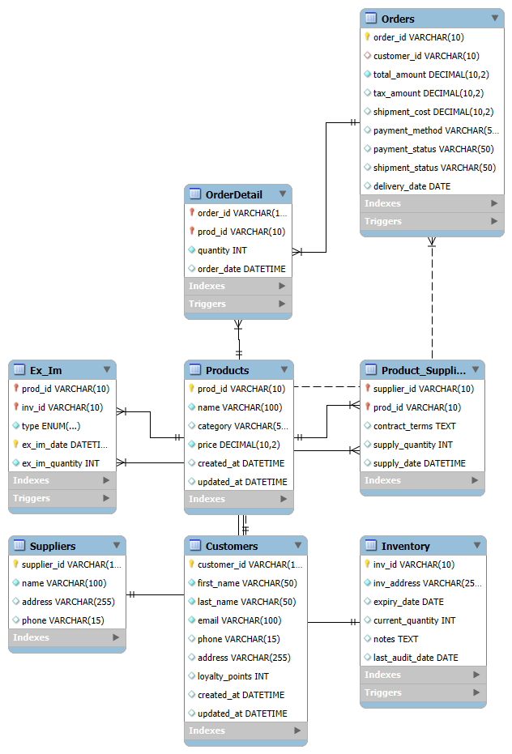

Implementation:
This chapter describes how the Beer Distribution Management System wasimplemented using a MySQL database, a FastAPI backend, and supporting Python libraries. The implementation focuses on three main components: the database layer, the API layer, and the libraries/tools used to connect them.

MySQL:
The MySQL database is the core of the system, storing all operational data and enforcing business rules. The database is designed using a relational model with strong use of stored procedures, functions, and triggers to ensure data integrity and automate business logic.

The system uses several relational tables:

Core Entities:
- Customers – Stores customer information and loyalty points.
- Products – Contains product data including categories and pricing.
- Orders – Represents high-level order information for each customer.
- Inventory – Tracks stock quantities for each warehouse.
- Suppliers – Suppliers providing products.

Relationships:
- Products ↔ Orders → via OrderDetail
- Products ↔ Inventory → via Ex_Im
- Products ↔ Suppliers → via Product_Supplier
Primary keys and foreign keys ensure strong referential integrity, using ON DELETE CASCADE to automate cleanup of related rows.

Stored Procedures
The system centralizes business logic inside MySQL using stored procedures. This ensures consistency and reduces backend complexity.

AddNewCustomer: Automatically generates a new ID (CUSXXX), inserts customer, returns new ID.

AddNewOrder: Generates new ID (ORDXXX) and inserts a new order header.

AddOrderDetail: Inserts product items into an order and recalculates the order total using the function fn_get_order_total.

ProcessExIm:
Handles Import/Export operations:
- Updates inventory quantity
- Inserts a log entry into Ex_Im

UpdateOrderStatus: Updates order payment and shipment status.
These procedures encapsulate logic so that the API only needs to call them without manually writing SQL business rules.

MySQL Functions
The system includes several helper functions used in triggers and API queries:

fn_get_order_total(order_id): Calculates order total based on quantities × product price.

fn_get_stock(prod_id): Returns real-time inventory (total import − total export).

fn_get_customer_total_spent(customer): Returns total amount spent by a customer.

fn_get_customer_order_count(customer): Counts how many orders the customer has placed.

fn_get_total_inventory(): Returns the sum of stock quantities across all warehouses.
These functions simplify calculations and make triggers more readable.

Triggers
Triggers are used to enforce automatic system rules.

Trg_update_inventory_after_exim: Whenever a new import/export record is inserted, update the inventory accordingly.

Trg_update_order_total: Recalculates order total after inserting a new OrderDetail row.

Trg_update_customer_loyalty: Adds loyalty points when an order changes to Paid status.

Trg_update_inventory_audit: Automatically updates last_audit_date whenever an inventory row is updated.
Triggers ensure that business rules execute automatically with no manual intervention.

API:
The backend API is implemented using FastAPI, which exposes database functionality to external systems or future frontend components.

API Structure:
The backend is organized into three layers:

API Layer: Defines HTTP endpoints and receives/sends JSON data.

Business Logic Layer: Minimal, since logic is mostly handled inside MySQL procedures and functions.

Database Access Layer: Handles database connections using PyMySQL, calls stored procedures, commits transactions, and returns results.
This 3-layer approach keeps the backend clean, modular, and easy to maintain.

API Endpoints
The system provides several REST API endpoints:

GET Endpoints
- /customers – Fetch all customers
- /orders – Fetch all orders
- /products – Fetch all products
- /inventory – Fetch inventory list
- /get-stock(prod_id) – Get real-time product stock

POST Endpoints
- /add-customer – Calls AddNewCustomer
- /add-order – Calls AddNewOrder
- /add-order-detail – Calls AddOrderDetail
- /process-exim – Calls ProcessExIm

PUT Endpoints
- /update-order-status – Calls UpdateOrderStatus

Database Calls from API
Each API endpoint follows the same pattern:
- Open MySQL connection
- Execute stored procedure or SQL
- Commit
- Return JSON response

Library:

PyMySQL
- Connects Python to MySQL
- Allows calling stored procedures
- Returns results as dictionaries (DictCursor)
- Handles transactions, queries, and data retrieval

FastAPI
Chosen because:
- Extremely fast (ASGI-based)
- Automatic documentation
- Easy to write and maintain
- Good JSON support

Uvicorn
ASGI server used to run the FastAPI application.

MySQL Workbench
Used to:
- Design schema
- Test procedures, functions, triggers
- Manually inspect database state

Conclusion:
The Beer Distribution Management System was successfully designed and implemented using a combination of MySQL, FastAPI, and Python. Through a structured three-layer backend architecture—API Layer, Business Logic Layer, and Database Access Layer—the system achieves modularity, maintainability, and clear separation of responsibilities.
The database implementation forms a strong foundation for the system. By using stored procedures, functions, and triggers, critical business logic is embedded directly into MySQL, ensuring consistency, automation, and data integrity without requiring complex backend logic. Inventory updates, order processing, customer loyalty management, and automated total calculations all operate reliably through database-level mechanisms.
The FastAPI backend provides a clean and modern interface for interacting with the database. With well-defined REST API endpoints, the system supports customer management, product retrieval, order creation, import/export handling, and real-time stock checking. The use of PyMySQL ensures smooth communication between the API and the database, while FastAPI’s built-in documentation enhances usability and testing.
Overall, this project demonstrates how a practical, real-world business system can be built efficiently by leveraging database-driven business logic and a lightweight API layer. The resulting system is scalable, easy to extend, and suitable for future integration with a frontend user interface or external systems. The combination of robust data modeling, automated workflows, and clean API design provides a solid foundation for further development and real deployment scenarios.

References:
- FastAPI Documentation. Available at: https://fastapi.tiangolo.com
- PyMySQL Documentation. Available at: https://pymysql.readthedocs.io/en/latest/
- Uvicorn ASGI Server. Available at: https://www.uvicorn.org
- MySQL 8.0 Reference Manual. Available at: https://dev.mysql.com/doc
- Recharts Documentation. Available at: https://recharts.org

